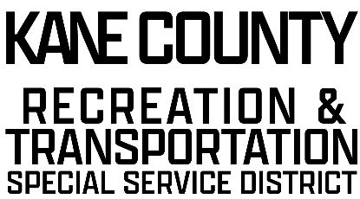

76 NORTH MAIN ST.

KANAB UT

84741

kcrtssd.specialservicedistrict.org

February 19, 2025 Board Meeting.

10:00 AM, Kane County Commission Chambers

76 N Main, Kanab, UT

AGENDA

* Call to Order
* Prayer
* Pledge of Allegiance
* Approval of 12-18-2024 RTSSD Meeting Minutes
* Financials
* Statement Review
* Checks Disbursement
* Funding Requests
* Discussion/Possible Approval of Kanab Mountain Bike Team Funding Request.
* Discussion/Possible Approval of Kanab City Tennis Court Resurface Funding Request.
* Discussion/Possible Approval of KCCA Funding Request.
* Adjourn

**This meeting is available for call in option – # 435-676-9000 –Enter participant code- 168030**