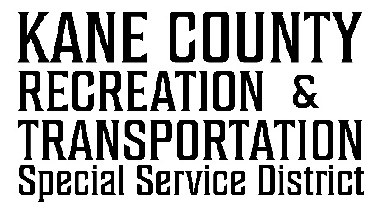

76 NORTH MAIN ST.

KANAB UT

84741

kcrtssd.specialservicedistrict.org

May 7, 2025 Board Meeting.

10:00 AM, Kane County Commission Chambers

76 N Main, Kanab, UT

**AGENDA**

* Call to Order

* Approval of 02-19-2025 RTSSD Meeting Minutes
* Financials
* Statement Review
* Funding Requests
* Discussion/Possible Approval of the Orderville Town Park Project Funding Request.
* Discussion/Possible Approval of the Duck Creek Village Porta Potties Funding Request.

* Adjourn

This meeting is available via Google Meet Video call link:

<https://meet.google.com/wcs-hrvr-ttg>

Or dial: